**DAILY ONLINE ACTIVITIES SUMMARY**

|  |  |  |  |  |  |  |  |
| --- | --- | --- | --- | --- | --- | --- | --- |
| **Date:** | **10-06-2020** | | | | **Name:** | **B.A.SOHANKUMAR** | |
| **Sem & Sec** | **4TH SEM A** | | | | **USN:** | **4AL18CS013** | |
| **Online Test Summary** | | | | | | | |
| **Subject** | | **OBJECT ORIENTED CONCEPT** | | | | | |
| **Max. Marks** | | **30** | | **Score** | | **18** | |
| **Certification Course Summary** | | | | | | | |
| **Course** | **ARTIFICIAL INTELLIGENCE IN PYTHON** | | | | | | |
| **Certificate Provider** | | | **GLA** | **Duration** | | | **7 HOURS** |
| **Coding Challenges** | | | | | | | |
| **Problem Statement:1:Write a C program to print the sum of boundary elements of a matrix.**  **Problem Statement:2:Write a java program to find the longest repeating sequence in a string.** | | | | | | | |
| **Status: EXECUTED** | | | | | | | |
| **Uploaded the report in Github** | | | | **YES** | | | |
| **If yes Repository name** | | | | **LOCKDOWN CODING** | | | |
| **Uploaded the report in slack** | | | | **YES** | | | |

**ONLINE TEST DETAILS:**

Test was on 3rd and 4th module of OBJECT ORIENTED CONCEPT (18CS45).The duration of the test was 30minutes from 09.15am to 09.45am.Questions were of multiple choice and all the questions were based on programming.Score I received is 18/30.

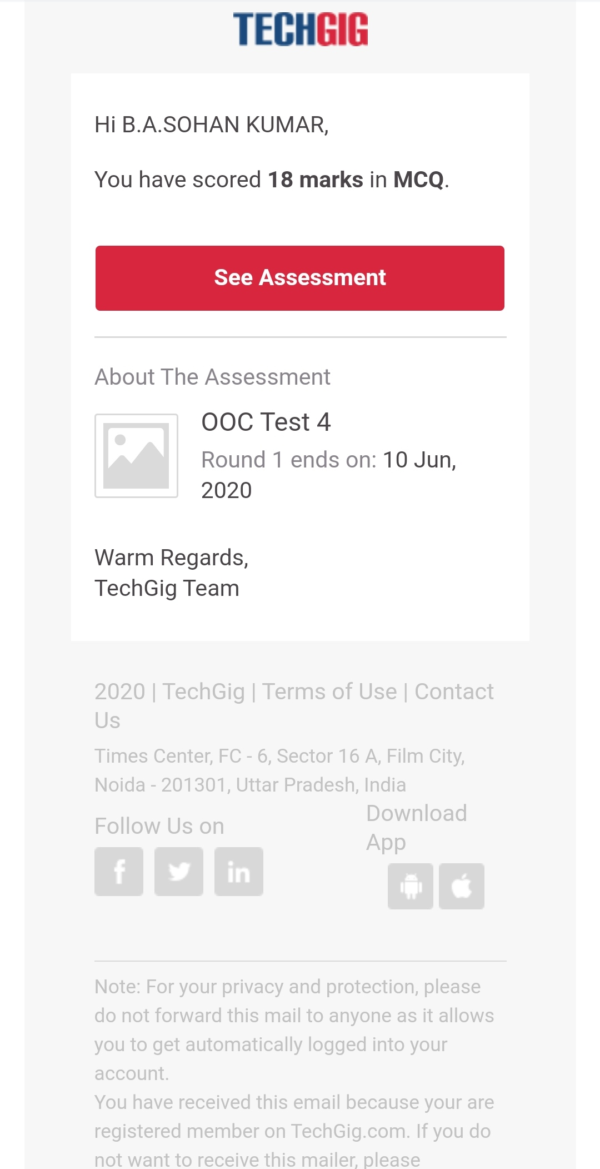

**ONLINE CERTIFICATION COURSE:**

Course: Artificial intelligence in python

Today completed modules are Forward Propagation,Loss Function,Demo Using Keras Framework,Back Propagation and gradient Descent,Tensorflow 2.0,Demo on Mnist Dataset and successfully completed the course by taking assessment quiz.

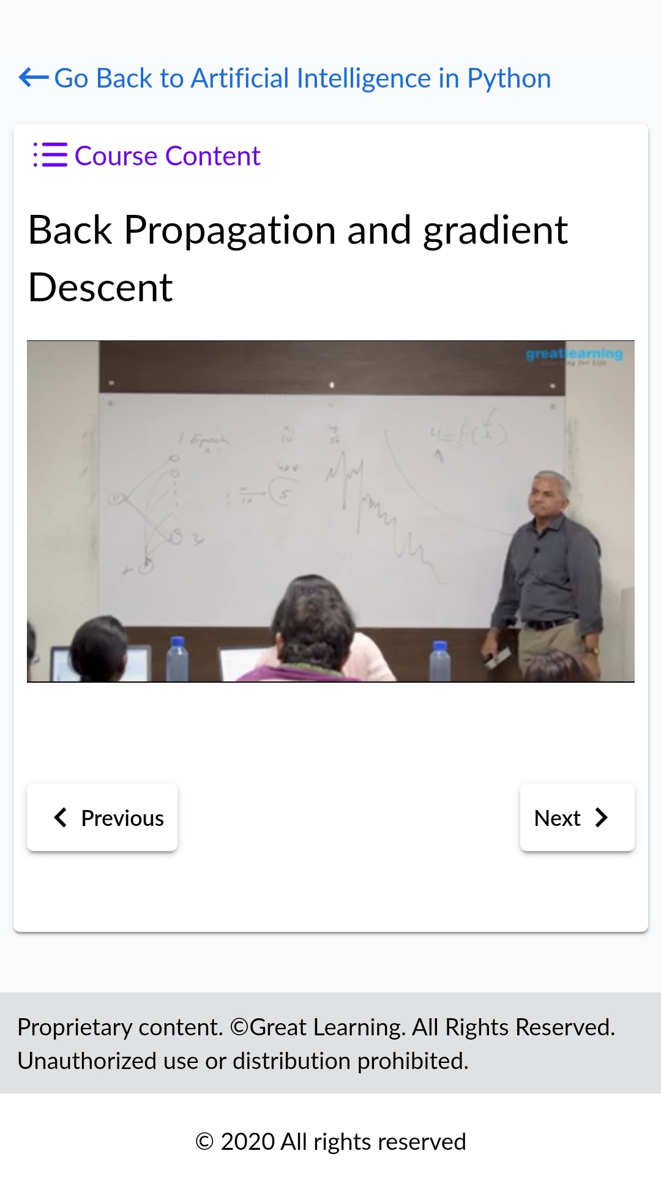 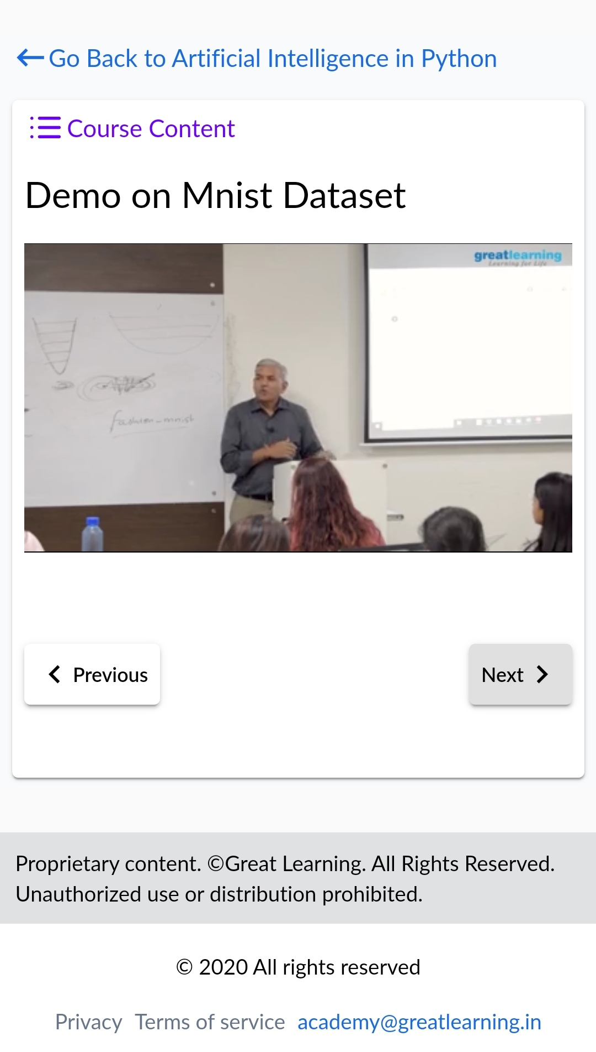

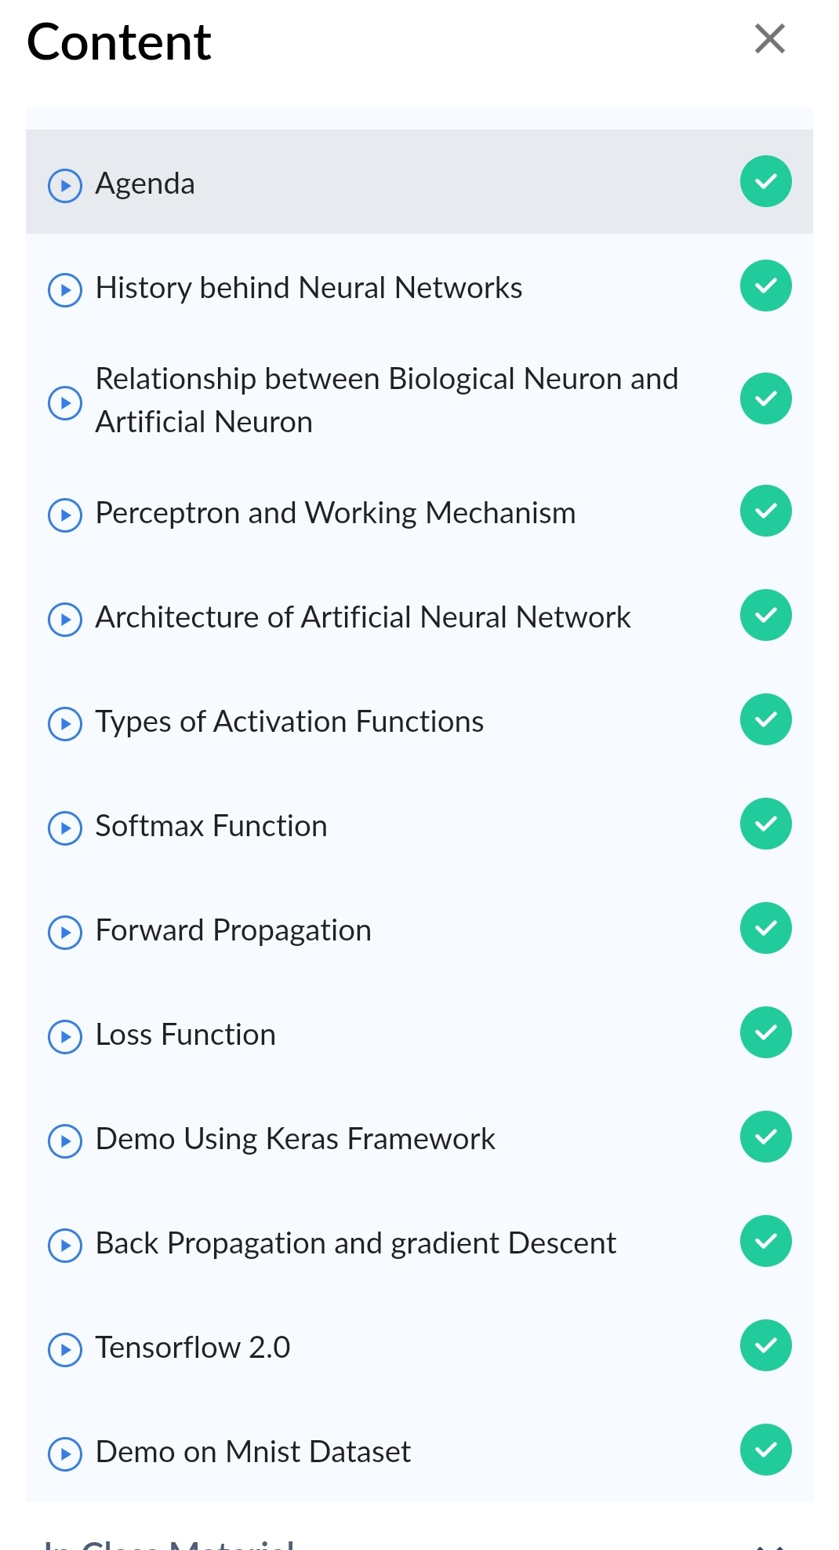

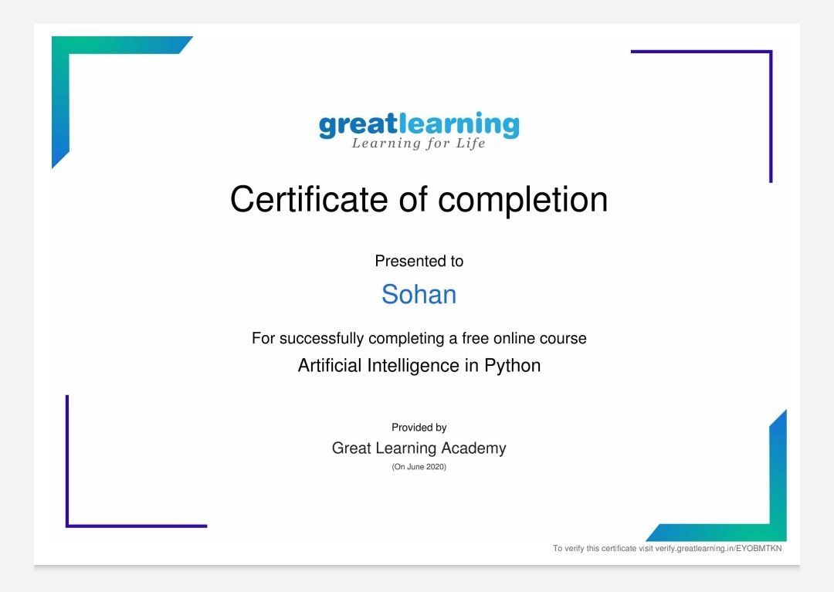

Above certificate is awarded for the completion of this course.

**CODING CHALLENGES DETAILS:**

1.Write a c program to print the sum of boundary elements of a matrix.Given a matrix, the task is to print the boundary elements of the matrix and display their sum.

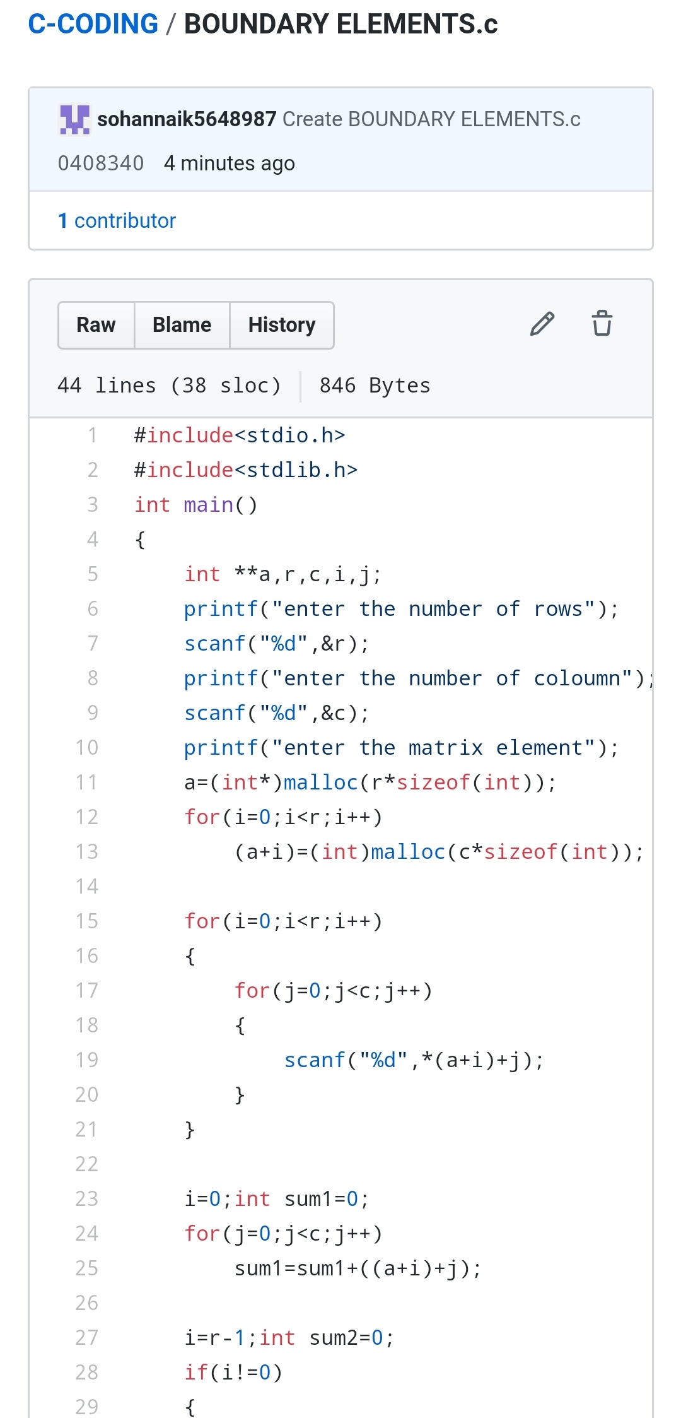

2.Write the java program to find the longest repeating sequence in a string.string:acbdfghybdf

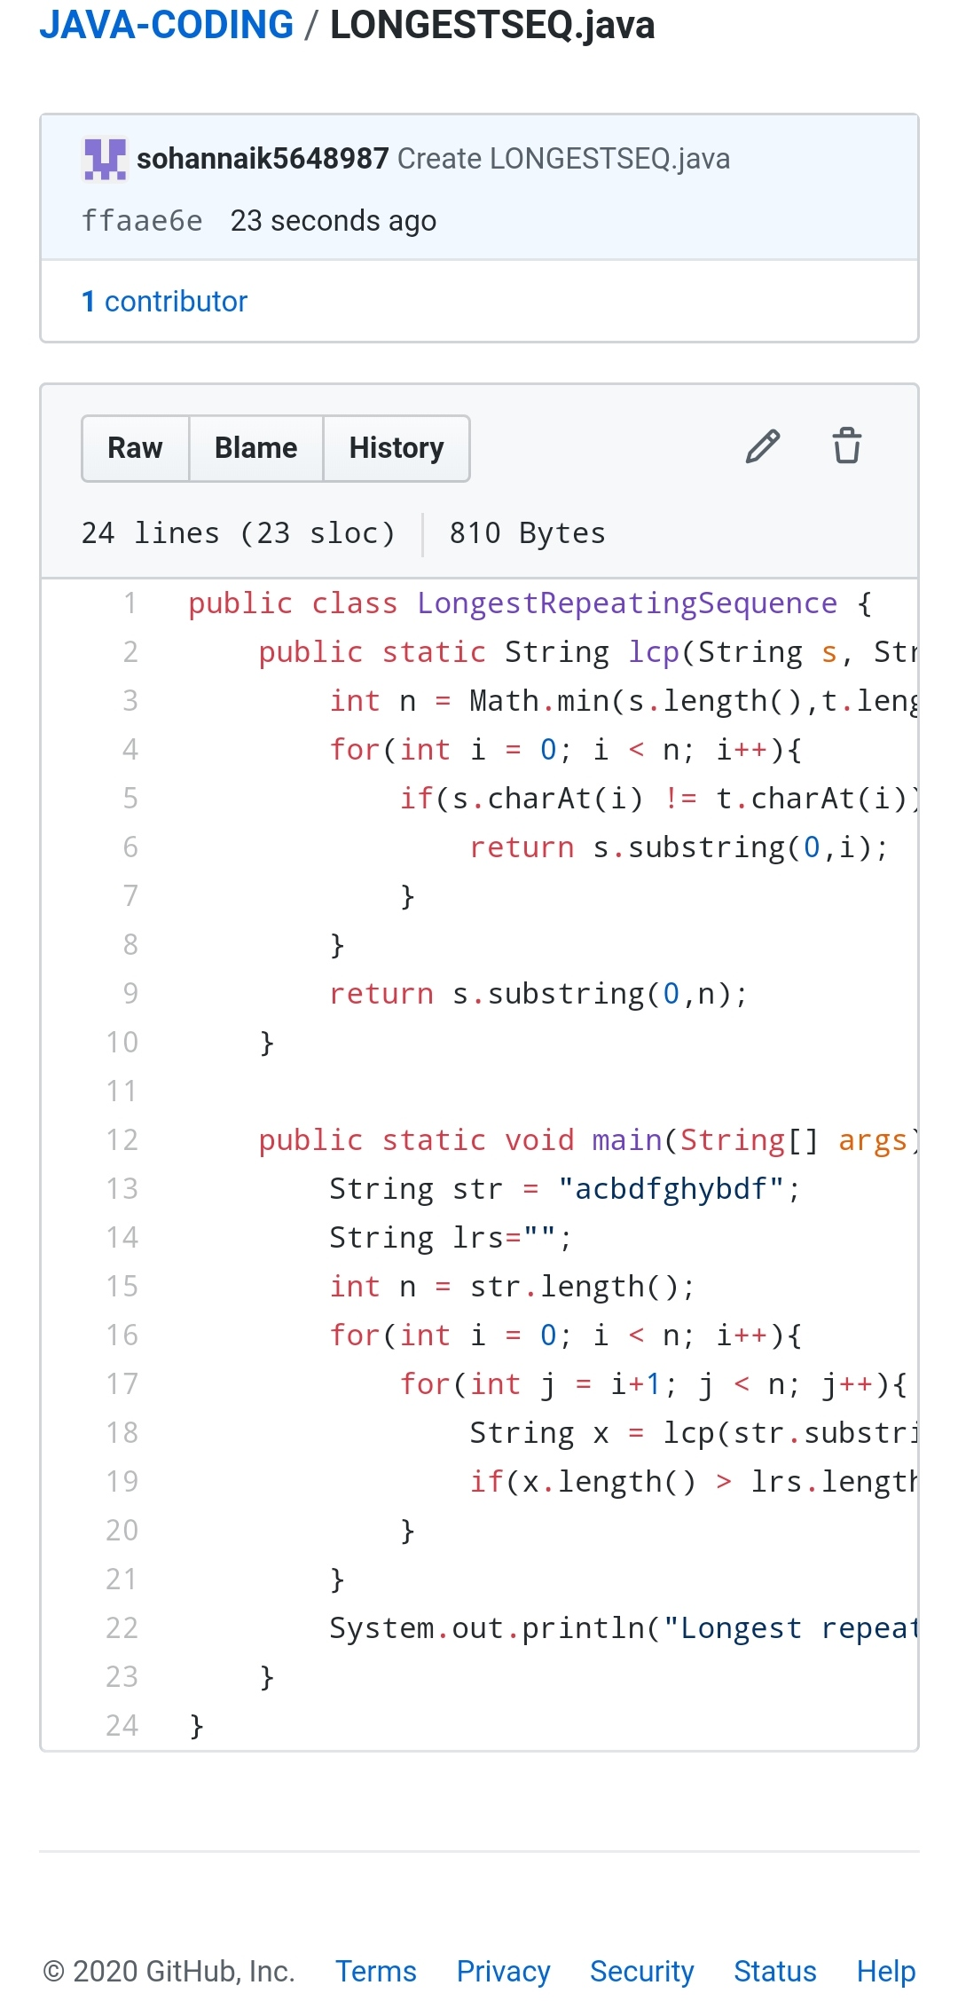

REPOSITORY LINK:https://github.com/sohannaik5648987/JAVA-CODING

https://github.com/sohannaik5648987/C-CODING